支持信息

基于Mathematica的偏振光现象动态仿真

商紫怡,于巾荔,陈映君,周兴玉*,洪许海

(辽宁师范大学 物理与电子技术学院，辽宁 大连，116029)

程序1：偏振光的二维合成
$$∆ϕ\text{=}π;$$
$$image[t_]:=Show[Graphics[\{$$
$$Blue,Thick,Arrow\left[\left\{\left\{0,0\right\},\left\{Cos\left[t\right],0\right\}\right\}\right],$$
$$Green,Thick,Arrow\left[\left\{\left\{0,0\right\},\left\{0,Cos\left[t+∆ϕ\right]\right\}\right\}\right],$$
$$Red,Thick,Arrow\left[\left\{\left\{0,0\right\},\left\{Cos\left[t\right],Cos\left[t+∆ϕ\right]\right\}\right\}\right],$$
$$Black,Dashed,Line\left[\left\{\left\{Cos\left[t\right],0\right\},\left\{Cos\left[t\right],Cos\left[t+∆ϕ\right]\right\}\right\}\right],$$
$$Black,Dashed,Line\left[\left\{\left\{0,Cos\left[t+∆ϕ\right]\right\},\left\{Cos\left[t\right],Cos\left[t+∆ϕ\right]\right\}\right\}\right]$$
$$\},PlotRange→\left\{\left\{-1,1\right\},\left\{-1,1\right\}\right\},Axes→True,Ticks→None,$$
$$AxesLabel→\left\{Style\left[\text{"x"},20,Black\right],Style\left[\text{"y"},20,Black\right]\right\}$$
$$],ParametricPlot\left[\left\{Cos\left[u\right],Cos\left[u+∆ϕ\right]\right\},\left\{u,0,t\right\},PlotStyle→\left\{Red,Thick\right\}\right]];$$
$$images=Table[image[t],\{t,2π/180,2π,2π/180\}];$$
$$Export[\text{"}\text{偏振光的二维合成（}相位差\text{=}π\text{）}\text{.gif}\text{"},images,$$
$$"DisplayDurations"→0.05,ImageSize→\{360,360\},"AnimationRepetitions"→6]$$

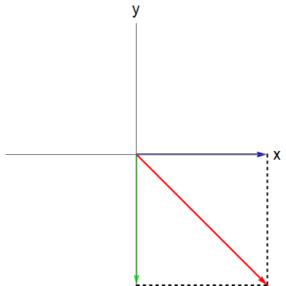
（a）$∆ϕ=π$

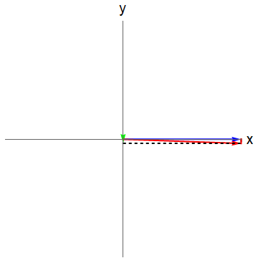
（b）$∆ϕ=π/2$

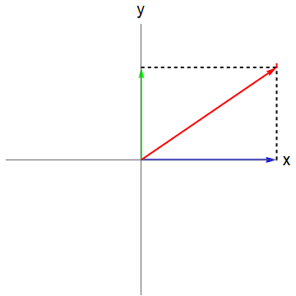
（c）$∆ϕ=π/4$
图S1 偏振光的二维合成
程序2：偏振光的三维形态
$$∆ϕ\text{=}π; r=π; zmax=4r; zmin=-r;$$
$$image[t_]:=Show[Graphics3D[\{$$
$$Table\left[\left\{Gray,Line\left[\left\{\left\{-r,y,0\right\},\left\{r,y,0\right\}\right\}\right]\right\},\left\{y,\left\{-r,-r/2,r/2,r\right\}\right\}\right],$$
$$Table\left[\left\{Gray,Line\left[\left\{\left\{x,-r,0\right\},\left\{x,r,0\right\}\right\}\right]\right\},\left\{x,\left\{-r,-r/2,r/2,r\right\}\right\}\right],$$
$$Table\left[\left\{Gray,Line\left[\left\{\left\{-r,0,z\right\},\left\{r,0,z\right\}\right\}\right]\right\},\left\{z,r,zmax,r\right\}\right],$$
$$Table\left[\left\{Gray,Line\left[\left\{\left\{x,0,0\right\},\left\{x,0,zmax\right\}\right\}\right]\right\},\left\{x,\left\{-r,r\right\}\right\}\right],$$
$$Table\left[\left\{Gray,Line\left[\left\{\left\{0,-r,z\right\},\left\{0,r,z\right\}\right\}\right]\right\},\left\{z,r,zmax,r\right\}\right],$$
$$Table[\{Gray,Line[\{\{0,y,0\},\{0,y,zmax\}\}]\},\{y,\{-r,r\}\}],$$
$$Red,Arrow\left[\left\{\left\{0,0,0\right\},\left\{rCos\left[t\right],rCos\left[t+Δϕ\right],0\right\}\right\}\right],$$
$$Table[\{Gray,Thin,Line[\{\{0,0,z\},\{rCos[t+(z-zmax)],$$
$$rCos[t+Δϕ+(z-zmax)],z\}\}]\},\{z,0,zmax,2π/90\}],$$
$$Text\left[Style\left[\text{"x"},13,Black,Bold\right],\left\{1.1r,0,0\right\}\right],$$
$$Text\left[Style\left[\text{"y"},13,Black,Bold\right],\left\{0,1.2r,0\right\}\right],$$
$$Text[Style["z",13,Black,Bold],\{0,0,1.03*zmax\}]$$
$$\},PlotRange→\left\{\left\{-r,r\right\},\left\{-r,r\right\},\left\{zmin,zmax\right\}\right\},Boxed→False,Axes→True,$$
$$AxesOrigin→\left\{0,0,0\right\},Ticks→None,ViewPoint→\left\{2,2,2\right\},ViewVertical→\left\{0,1,0\right\}$$
$$],ParametricPlot3D[\{x,0,z\},\{x,-r,r\},\{z,0,zmax\},Mesh→None,$$
$$PlotStyle→\{Blue,Opacity[0.025]\}],$$
$$ParametricPlot3D[\left\{0,y,z\right\},\left\{y,-r,r\right\},\left\{z,0,zmax\right\},Mesh→None,$$
$$PlotStyle→\left\{Green,Opacity\left[0.025\right]\right\}],$$
$$ParametricPlot3D[\left\{rCos\left[u\right],rCos\left[u+Δϕ\right],0\right\},\left\{u,0,t\right\},$$
$$PlotStyle→\left\{Red,Thick\right\}],$$
$$ParametricPlot3D[\{rCos[t+(z-zmax)],rCos[t+Δϕ+(z-zmax)],z\},\{z,0,zmax\},$$
$$PlotStyle→\{Red,Thick\}]];$$
$$images=Table[image[t],\{t,2π/90,2π,2π/90\}];$$
$$Export["偏振光的三维形态（相位差=π）.gif",images,$$
$$"DisplayDurations"→0.05,ImageSize→\{720,720\},"AnimationRepetitions"→6]$$

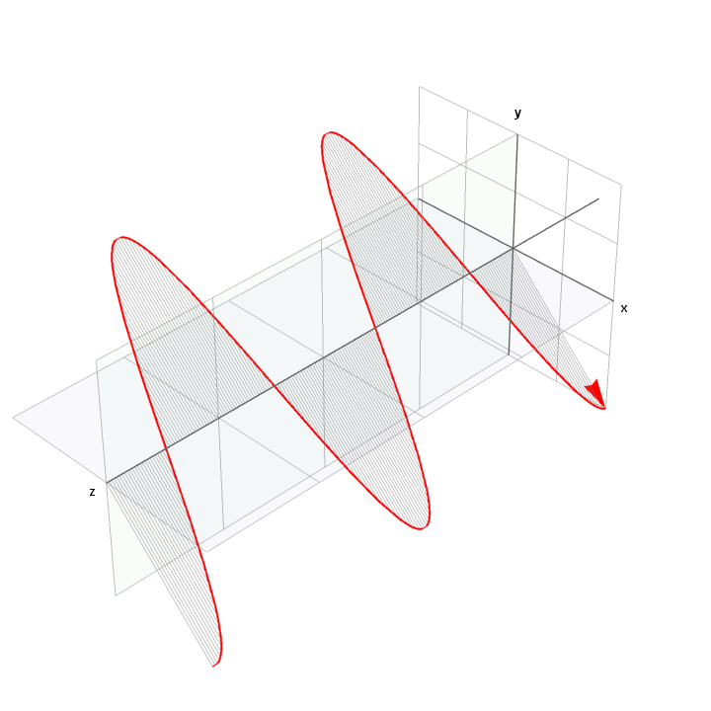
（a）$∆ϕ=π$
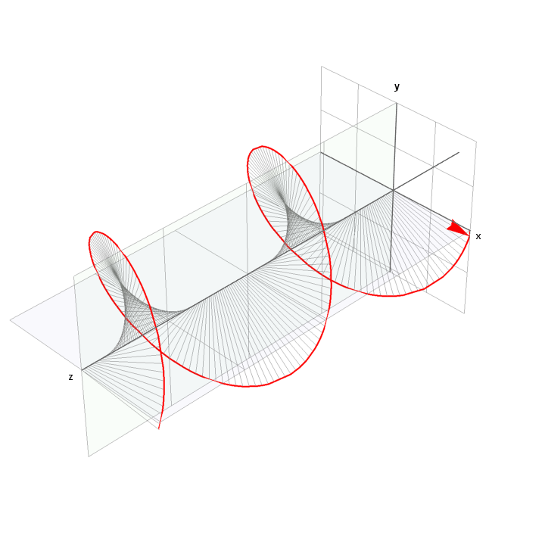
（b）$∆ϕ=π/2$
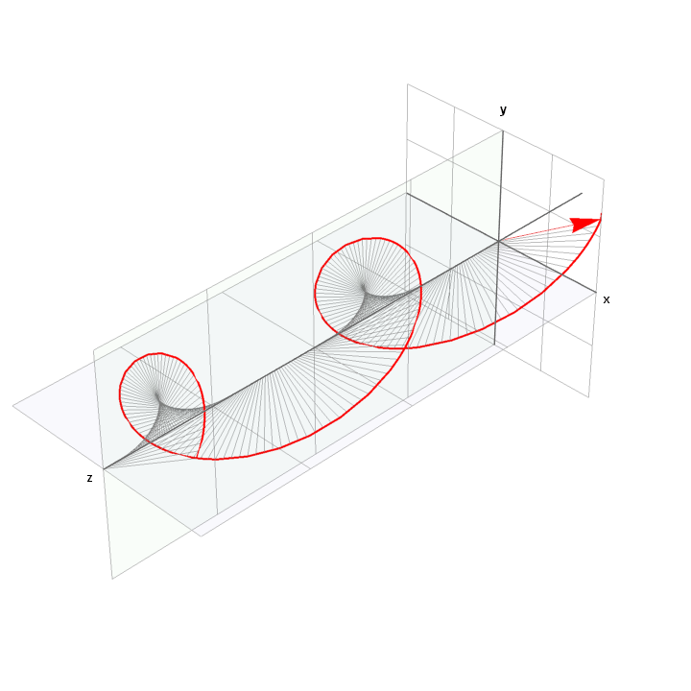
（c）$∆ϕ=π/4$
图S2：偏振光的三维形态
程序3：线偏振光通过一个偏振片
$$r1=1; r2=1.5;$$
$$image[α_]:=Show[$$
$$DensityPlot[{\left(Cos\left[α\right]\right)}^{2},\{x,-2,2\},\{y,-2,2\},RegionFunction→Function\left[\left\{x,y\right\},x^{2}+y^{2}≤{r1}^{2}\right],$$
$$ColorFunction→\left(GrayLevel\left[\#\right]\&\right),ColorFunctionScaling→False,$$
$$PlotLabel→Style[Framed[Row[\{"α = ",α/π*180,Degree\}]],20,Blue,$$
$$Background→Lighter[Yellow]],Frame→None,BoundaryStyle→Black],$$
$$DensityPlot[0,\{x,-2,2\},\{y,-2,2\},RegionFunction→Function[\{x,y\},{r1}^{2}≤x^{2}+y^{2}<{r2}^{2}],$$
$$ColorFunction→(GrayLevel[\#]\&),BoundaryStyle→Black],$$
$$Graphics[\{$$
$$Gray,Thickness\left[0.0125\right],Line[\{\left\{r1Cos\left[α+π/2\right],r1Sin\left[α+π/2\right]\right\},$$
$$\left\{r2Cos\left[α+π/2\right],r2Sin\left[α+π/2\right]\right\}\}],$$
$$Gray,Thickness\left[0.0125\right],Line[\{\{r1Cos[α+3π/2],r1Sin[α+3π/2]\},$$
$$\{r2Cos[α+3π/2],r2Sin[α+3π/2]\}\}]\}]];$$
$$images=Table[image[α],\left\{α,0,2π,2π/180\right\}];$$
$$Export["线偏振光通过一个偏振片（白光）.gif",images,$$
$$"DisplayDurations"→0.1,ImageSize→\{360,360\},"AnimationRepetitions"→6]$$

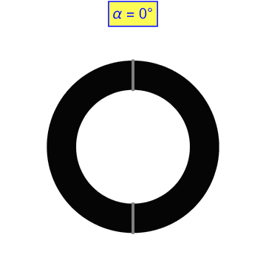
（a）入射光为白光

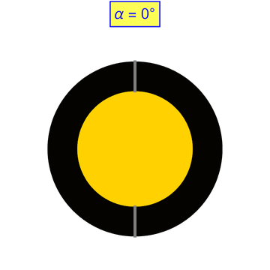
（b）入射光为黄光
图S3 线偏振光通过一个偏振片

程序4：自然光通过两个偏振片
$$r1=1; r2=1.2; O1x=-0.5; O1y=0; O2x=0.5; O2y=0;$$
$$image[α_]:=Show[$$
$$DensityPlot[{\left(Cos\left[α\right]\right)}^{2},\{x,-2,2\},\{y,-2,2\},RegionFunction→Function[\left\{x,y\right\},$$
$$\left({\left(x-O1x\right)}^{2}+{\left(y-O1y\right)}^{2}≤{r1}^{2}\right)\&\&\left({\left(x-O2x\right)}^{2}+{\left(y-O2y\right)}^{2}≤{r1}^{2}\right)],$$
$$ColorFunction→\left(GrayLevel\left[\#\right]\&\right),ColorFunctionScaling→False,$$
$$PlotLabel→Style[Framed\left[Row\left[\left\{\text{"}\text{a}\text{1 = "},0,Degree," and ","\text{a2 }\text{= "},α/π*180,Degree\right\}\right]\right],$$
$$20,Blue,Background→Lighter[Yellow]],Frame→None,BoundaryStyle→Black],$$
$$DensityPlot[1,\{x,-2,2\},\{y,-2,2\},RegionFunction→Function[\{x,y\},$$
$$({\left(x-O1x\right)}^{2}+{\left(y-O1y\right)}^{2}≤{r1}^{2})\&\&(!({\left(x-O2x\right)}^{2}+{\left(y-O2y\right)}^{2}≤{r1}^{2}))],$$
$$ColorFunction→\left(GrayLevel\left[\#\right]\&\right),ColorFunctionScaling→False,$$
$$BoundaryStyle→Black],$$
$$DensityPlot[1,\{x,-2,2\},\{y,-2,2\},RegionFunction→Function[\{x,y\},$$
$$(!({\left(x-O1x\right)}^{2}+{\left(y-O1y\right)}^{2}≤{r1}^{2}))\&\&({\left(x-O2x\right)}^{2}+{\left(y-O2y\right)}^{2}≤{r1}^{2})],$$
$$ColorFunction→\left(GrayLevel\left[\#\right]\&\right),ColorFunctionScaling→False,$$
$$BoundaryStyle→Black],$$
$$DensityPlot[0,\{x,-2,2\},\{y,-2,2\},RegionFunction→Function[\{x,y\},$$
$${r1}^{2}≤{\left(x-O1x\right)}^{2}+{\left(y-O1y\right)}^{2}<{r2}^{2}],$$
$$ColorFunction→(GrayLevel[\#]\&),BoundaryStyle→Black],$$
$$DensityPlot[0,\{x,-2,2\},\{y,-2,2\}, RegionFunction→Function[\left\{x,y\right\},$$
$${r1}^{2}≤{\left(x-O2x\right)}^{2}+{\left(y-O2y\right)}^{2}<{r2}^{2}],$$
$$ColorFunction→\left(GrayLevel\left[\#\right]\&\right),BoundaryStyle→Black],$$
$$Graphics[\{$$
$$Grey,Thickness[0.0125],Line[\{\{O1x+r1Cos\left[θ+π/2\right],O1y+r1Sin\left[θ+π/2\right]\},$$
$$\left\{O1x+r2Cos\left[θ+π/2\right],O1y+r2Sin\left[θ+π/2\right]\right\}\}],$$
$$Grey,Thickness[0.0125],Line[\{\{O1x+r1Cos[θ+3π/2],O1y+r1Sin[θ+3π/2]\},$$
$$\{O1x+r2Cos[θ+3π/2],O1y+r2Sin[θ+3π/2]\}\}],$$
$$Grey,Thickness[0.0125],Line[\{\{O2x+r1Cos[α+π/2], O2y+r1Sin[α+π/2]\},$$
$$\{O2x+r2Cos[α+π/2],O2y+r2Sin[α+π/2]\}\}],$$
$$Grey,Thickness[0.0125],Line[\{\{O2x+r1Cos[α+3π/2],O2y+r1Sin[α+3π/2]\},$$
$$\{O2x+r2Cos[α+3π/2],O2y+r2Sin[α+3π/2]\}\}]\}]];$$
$$images=Table[image[α],\{α,0,2π,2π/180\}];$$
$$Export["\text{自然光通过两个偏振片}\text{（白光）}.gif",images,$$
$$"DisplayDurations"→0.1,ImageSize→\{360,360\},"AnimationRepetitions"→6]$$

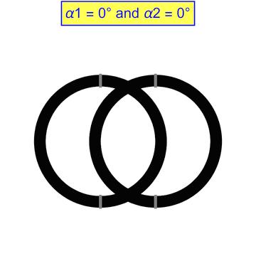
（a）入射光为白光

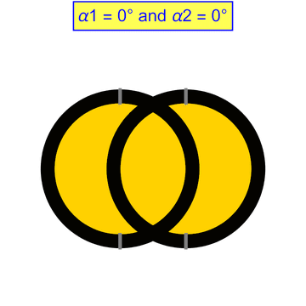
（b）入射光为黄光
图S4 自然光通过两个偏振片

程序5：光在单轴晶体中的二维波面
$$tmin=0.025; tmax=1;$$
$$image[t_]:=Graphics[\{$$
$$Blue,Thick,Circle\left[\left\{0,0\right\},\left\{1.5t,t\right\}\right],$$
$$Green,Thick,Circle\left[\left\{0,0\right\},t\right],$$
$$Red,Disk\left[\left\{0,0\right\},tmin\right],$$
$$Blue,Thickness[Medium],Arrowheads\left[0.015\right],$$
$$Table[Arrow[\{\{tminCos[θ],tminSin[θ]\},\{1.5tCos[θ],tSin[θ]\}\}],\{θ,0,3π/2,π/2\}],$$
$$Green,Thickness[Medium],Arrowheads\left[0.015\right],$$
$$Table[Arrow[\{\{tminCos[θ],tminSin[θ]\},\{tCos[θ],tSin[θ]\}\}],\{θ,π/4,7π/4,π/2\}],$$
$$Blue,Table[Table[Line[\{\{1.5iCos[θ],-tmin\},\{1.5iCos[θ],tmin\}\}],$$
$$\{i,0.1,t-0.01,0.1\}],\{θ,\{0,π\}\}],$$
$$Blue,Table[Table[Line[\{\{-tmin,iSin[θ]\},\{tmin,iSin[θ]\}\}],$$
$$\{i,0.1,t-0.01,0.1\}],\{θ,\{π/2,3π/2\}\}],$$
$$Green,Table[Table[Disk\left[\left\{iCos\left[θ\right],iSin\left[θ\right]\right\},tmin/2\right],$$
$$\left\{i,0.1,t-0.01,0.1\right\}], \left\{θ,π/4,7π/4,π/2\right\}]$$
$$\},PlotRange→\left\{\left\{-1.8tmax,1.8tmax\right\},\left\{-1.2tmax,1.2tmax\right\}\right\},$$
$$PlotLabel→Row[\{Style["—e光",15,Blue,Bold]," ",Style["—o光",15,Green,Bold]\}]];$$
$$images=Table[image[t],\{t,tmin,tmax,(tmax-tmin)/195\}];$$
$$Export["光在单轴（负）晶体中的二维波面.gif",images,$$
$$"DisplayDurations"→0.05,ImageSize→\{720,480\},"AnimationRepetitions"→6]$$

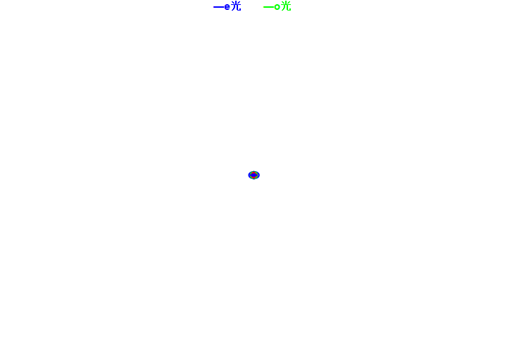
（a）单轴负晶体

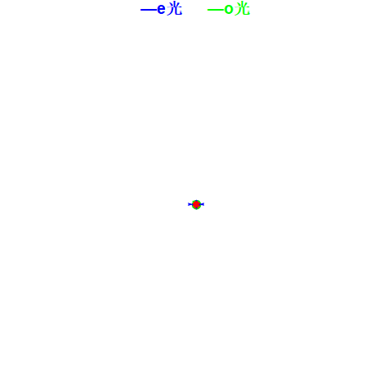
（b）单轴正晶体
图S5 光在单轴晶体中的二维波面
程序6：光在单轴晶体中的三维波面
$$tmin=0.05; tmax=1;$$
$$image[t_]:=Graphics3D[\{$$
$$Blue,Opacity\left[0.1\right],Ellipsoid\left[\left\{0,0,0\right\},\left\{1.5t,1.5t,t\right\}\right],$$
$$Yellow,Opacity\left[0.5\right],Sphere\left[\left\{0,0,0\right\},t\right],$$
$$Red,Opacity\left[1\right],Sphere\left[\left\{0,0,0\right\},tmin\right]$$
$$\},PlotRange→\left\{\left\{-1.5tmax,1.5tmax\right\},\left\{-1.5tmax,1.5tmax\right\},\left\{-tmax,tmax\right\}\right\},$$
$$PlotLabel→Row[\{Style["e光:淡蓝色",15,Black,Bold]," ",$$
$$Style["o光:浅黄色",15,Black,Bold]\}],$$
$$Boxed→False,ViewPoint→Front];$$
$$images=Table[image[t],\{t,tmin,tmax,(tmax-tmin)/190\}];$$
$$Export["光在单轴（负）晶体中的三维波面.gif",images,$$
$$"DisplayDurations"→0.05,ImageSize→\{720,720\},"AnimationRepetitions"→6]$$

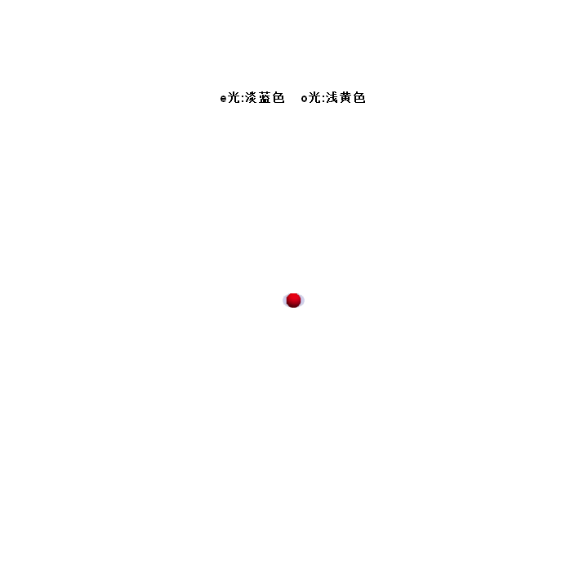
（a）单轴负晶体

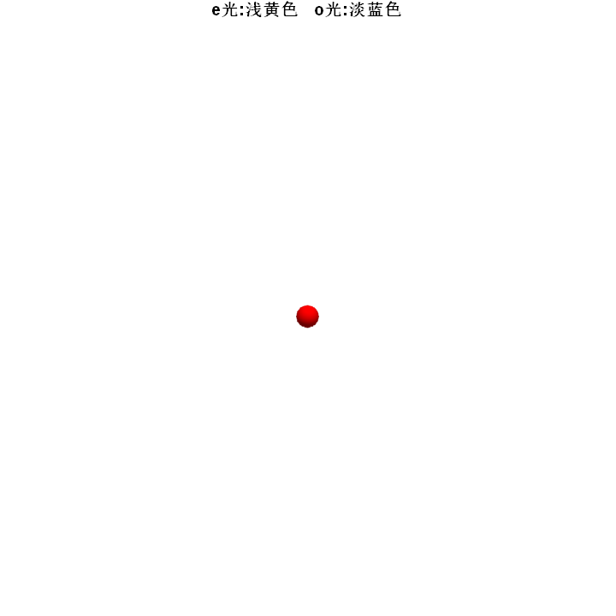
（b）单轴正晶体
图S6 光在单轴晶体中的三维波面

